**INDIA’S FREE TRADE AGREEMENTS (FTA) AND THE INDIAN STAINLESS STEEL INDUSTRY**

1. **Current status of operational FTAs**

* India already hasFTAs with Korea, Japan and ASEAN countries which have been operational since 2009-10. It is now in the advanced stage of negotiations for Regional Comprehensive Economic Partnership (RCEP) agreement which includes ASEAN + 5 partner countries (China, Korea, Japan, Australia & New Zealand). ***Currently there is No FTA with China.***
* Amongst the negotiating countries, there are major stainless steel producers like China, Japan, Korea & ASEAN bloc.
* Though the FTAs were envisaged to promote trade between the two countries, much of the trade post FTA has been one sided and India has substantial trade deficit with both Korea and Japan and this is only widening with each passing day as is shown in the table below:

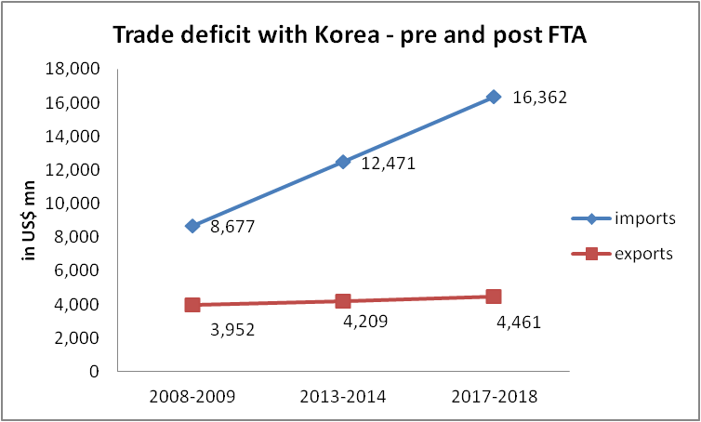

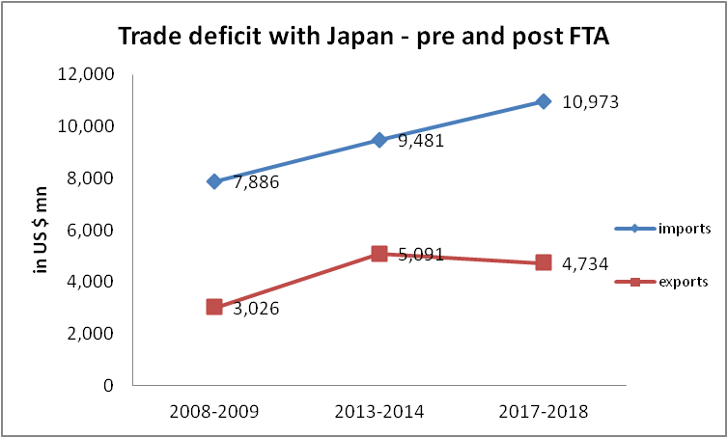

* It is apparent that the trade deficit has widened considerably since we entered into FTAs and this is also reflected in the trade deficit for stainless steel flat products which shows a similar trajectory :

1. **Situation with respect to RCEP Partner countries**

* A combination of tariff concessions under FTAs coupled with an increased incidence of subsidised and dumped imports from China resulted in the highest ever import of stainless steel flat products of 5,32,033 MT in 2015-16.
* In response to the surge in imports of dumped, subsidised and sub standard stainless steel flat products, the Indian government imposed a slew of measures including Anti-Dumping Duties (ADD), Countervailing duties (CVD), Quality Control Order (QCO), Anti - circumvention measures, etc. Importers were not only trying to sell dumped goods and subsidized goods in the country but were also circumventing the ADD imposed on such imports.
* The CVD investigation conducted by the Indian government clearly established the existence of subsidies in China. A total of 81 subsidies were examined in the final findings. Based on this, the Countervailing duty to the tune of 18.95% was imposed on import of stainless steel flat products from China vide notification dated 7th Sept 2017.
* Despite the imposition of various trade remedial measures, imports still constitute 19-20% of the domestic market which shows that these trade remedial measures have proven to be virtually ineffective.
* A study of the Anti Dumping cases in Stainless Steel in India over the last 10 years will clearly reveal that countries like China, Korea, Malaysia (ASEAN) etc, have indulged in repetitive dumping behaviour as can be seen in the slew of measures imposed by the Indian government:



* Further, the countries with whom we have an FTA or with whom FTA is being proposed are also countries which are riddled with excess capacities and surplus production posing a huge threat to the Indian market. The tables given below depict the scenario for Cold Rolled Stainless steel in Korea, Japan and China:

|  |  |  |  |  |  |  |
| --- | --- | --- | --- | --- | --- | --- |
| **Cold Rolled Stainless Steel segment in Japan (in'000 tonnes)** | | | | | | |
|  | **2012** | **2013** | **2014** | **2015** | **2016** | **2017** |
| Production | 1374 | 1398 | 1443 | 1369 | 1358 | 1465 |
| Apparent Consumption | 1045 | 1101 | 1127 | 1030 | 1047 | 1136 |
| Surplus | 329 | 297 | 316 | 339 | 311 | 329 |
|  |  |  |  |  |  |  |
|  |  |  |  |  |  |  |
| **Cold Rolled Stainless Steel segment in Korea (in'000 tonnes)** | | | | | | |
|  | **2012** | **2013** | **2014** | **2015** | **2016** | **2017** |
| Production | 1160 | 1120 | 1129 | 1186 | 1219 | 1278 |
| Apparent Consumption | 795 | 860 | 927 | 900 | 964 | 1007 |
| Surplus | 365 | 260 | 202 | 286 | 255 | 271 |
|  |  |  |  |  |  |  |
| **Cold Rolled Stainless Steel segment in China (in'000 tonnes)** | | | | | | |
|  | **2012** | **2013** | **2014** | **2015** | **2016** | **2017** |
| Production | 8147 | 9723 | 10876 | 10883 | 12381 | 13309 |
| Apparent Consumption | 7901 | 9201 | 9836 | 10037 | 11349 | 12248 |
| Surplus | 246 | 522 | 1040 | 846 | 1032 | 1061 |
|  |  |  |  |  |  |  |
| *Source: CRU International* | |  |  |  |  |  |

* A similar situation exists in Hot Rolled Stainless Steel flat products where major RCEP partner countries are all net exporters:



* It is against this scenario that India is negotiating RCEP with the ASEAN block, China, Korea and Japan (besides Australia and New Zealand). From the facts and the data shown above, it is clear that all these countries are riddled with excess capacity and have excess production. They have also been held guilty of repetitive dumping behaviour. All these conclusions put together indicate a very strong likelihood of additional injury if any tariff concessions are granted to them under the FTA.
* The current situation of trade deficit with China (in stainless steel flat products) is clearly ominous and there is a need to take a very measured approach before signing a FTA with them:

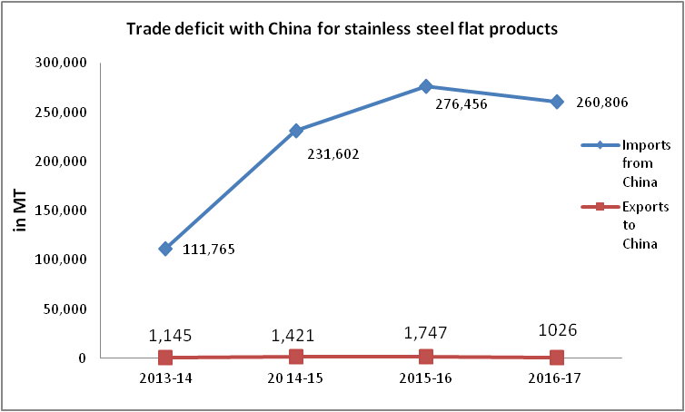

* ***Currently all imports from China are at MFN rate. No preferential tariffs have been given to China. If imports are this high at MFN rate, one can only imagine the onslaught if tariffs are reduced.***

|  |  |  |  |  |  |
| --- | --- | --- | --- | --- | --- |
| Capacity utilization of China (%) | | | | | |
| **2012** | **2013** | **2014** | **2015** | **2016** | **2017** |
| 73 | 68 | 72 | 66 | 71 | 71 |

* The build up of excess capacity in China has happened over last decade. From being a net importer of Stainless steel products in 2009, today China is a net exporter with an excess production of close to 3 million tons. The figures of capacity utilization for Chinese stainless steel mills are given below:
* Chinese mills are operating only at a 66% capacity utilisation indicating huge mis-match between the domestic demand and the installed capacity (table below from CRU data). One can only gauge the situation in case China starts using their capacity to the maximum.
* This exportable surplus finds itself into growing markets like India distorting the domestic markets completely.
* This distortion is not only due to the surplus production but also due to favourable duty structure in China on both raw materials as well as finished goods (table below).

|  |  |  |
| --- | --- | --- |
|  | **China** | **India** |
| **Finished Goods** |  |  |
| Stainless Steel Flat Products | 10% | 7.5% |
| **Raw Materials** |  |  |
| Steel Scrap | NIL | 2.5% |
| Stainless Steel Scrap | NIL | 2.5% |
| Ferro Molybdenum | 2% | 5% |

* Chinese stainless steel manufacturers also enjoy other advantages in the form of significantly lower interest cost, low power and logistics cost, availability of good quality coking coal etc. Some of these advantages are highlighted below:
* **Power**

**Power cost** in China is at least 30% lower as compared to India. This is so because the power prices are kept at an artificially low level because of Government controls on fixation of power tariffs. Power is an essential input both for the manufacture of stainless steel as well as for the manufacture of various intermediate products like ferro chrome and ferro nickel.

* **Finance and hedging cost**

**Borrowing cost** in China at around 4-5% is far lower, as compared to India where it is in the region of 12-13%. **The Chinese currency** has been relatively stable against the US Dollar and therefore Chinese manufacturers do not have to incur any hedging cost. However, the volatility of the Indian rupee against other currencies has increased the hedging cost for the domestic Stainless Steel Industry (currently in the region of **4.5%** p.a). Considering the overwhelming share of raw material to overall cost (around 70-75%) and dependence on imported raw material, it is only too obvious that that the competitive edge of the Domestic Stainless Steel industry has been completely blunted.

A comparison of finance cost (interest rates) in India vis-à-vis Japan, Korea and China is plotted below:



*Source :Worldbank.org*

*The rates for India are the applicable interest rates and as can be seen are much higher in comparison to RCEP partner countries*

* **Logistics**

It is well known that the logistics cost in India is much higher than that of other comparable economies. The most common benchmark for judging logistics performance is the **Logistics Performance Index (LPI)**. The **Logistics Performance Index (LPI)** score is an aggregation of several factors like customs, infrastructure, international shipments, logistics quality competence etc. The lower rank of India (especially with reference to RCEP partner countries) indicates the problem being faced by Indian exporters and importers.

**Source : Connecting to compete 2018 , Worldbank.org**

* Furthermore, Anti subsidy and Anti dumping measures have been initiated against China by several other countries which indicate that China has been indulging in dumping in other countries as well. The table below is an indicative list of a few such actions against China:

**INITIATING**

**COUNTRY**

**PRODUCT**

**DATE**

**COUNTRY**

Vietnam

cold-rolled stainless steel

25.12.2013

China, Indonesia, Malaysia

and Chinese Taipei.

Brazil

Cold-Rolled stainless steel

04.10.2013

Germany China, Korea,

Finland, Taiwan and Vietnam

USA

Circular Welded austentitic SS pressure pipe

17/03/2009

China

EU

Cold rolled stainless steel flat products

China

USA

Circular Welded austentitic SS pressure pipe

23/7/2014

USA

Drawn Stainless Steel Sinks

4/11/2013

China

USA

Drawn Stainless Steel Sinks

4/11/2013

China

EU

Seamless pipes, of iron or steel, with an

external diameter exceeding 406.4 mm

China

EU

Seamless pipes and tubes of stainless

steel

China

* There are aggressive Korean investments in ASEAN – Thailand & Vietnam. The investments in these countries are protected by artificially high tariff. Even with AIFTA, tariff rates will not be reduced below 5% in Thailand and Vietnam. While India has offered zero duty access in stainless steel to ASEAN countries, the benefits have not been reciprocated.
* Non Tariff barriers in the form of technical regulations / standards have been imposed in the ASEAN region.
* After the imposition of the Anti circumvention and CVD measures by India, China is now routing their imports through ASEAN countries like Indonesia which is apparent from the figures tabulated below:

**Import of Stainless Steel Flat Products from Indonesia (in MT)**

|  |  |  |  |
| --- | --- | --- | --- |
| **HS Tariff** | **Jan’17- June’17** | **Jan’18 to June’18** | **% increase** |
| 7219  & 7220 | 770 | 20,151 | 2517% |

*Source: Customs Data as procured from Cybex Exim Solutions*

* This definitely cannot be attributed to the zero duty benefits offered by India as part of the AIFTA since the AIFTA has been operational since 2010. An attribution analysis lays bare the following stark facts:

* + - New Chinese investments have come up in Indonesia which is facilitated by subsidies being doled out by both the Chinese and Indonesian Governments. It has been reported that Tsingshan Group investment in Indonesia alone aims to produce 3 mn tons of stainless steel. Along with other producers, the total production in Indonesia would touch 6mn tons by 2020.
    - Since the market for stainless steel in Indonesia is very limited, the surplus production in Indonesia is likely to lead to an increase in imports of stainless steel to India.
    - China is making these huge investments in Indonesia in order to leverage the availability of the Indonesia’s natural resources like low grade Nickel ore available at a low cost. It is therefore clear that the investment is linked to a natural advantage.
    - Both US and EU markets are now blocked out because they have put trade protection measures in place and these markets are also plagued by stagnant demand and excess capacity.
    - Other major countries like Japan and Korea are net exporters of stainless steel and even the ASEAN bloc is riddled with excess capacity.

Hence, it can be concluded that the capacity build up in Indonesia will be targeted at big and fast growing markets like India and therefore capacity expansion in Indonesia becomes a much bigger threat.

1. **FTAs and investment**

* The agreements with Korea and Japan are not merely free trade agreements for trade in goods and services but have a larger economic implication encompassing both trade and investment. It was therefore expected that FDI inflows would be maximum from FTA partner countries. However, in 2015-16, the bulk of the FDI inflow into the country was reported from non FTA countries (USD 21,530 mn, almost 70% of the total FDI inflow of US 36,068 mn) (Source : www.rbi.org.in) This clearly indicates that the FDI inflow is not on account of the FTA agreement. The trigger for FDI is not FTAs but the great growth story which India has to offer.
* The zero duty access provided to FTA partner countries in stainless steel flat products should have facilitated investment in downstream products of stainless steel. Contrary to these expectations, there has been a spurt in imports of downstream products like Stainless steel welded Pipes and tubes. This goes on to show that the only impact of these FTAs has been to flood the entire value chain with imported material which is further aided by tariff concessions. Thereby, the imports now dominate both the upstream (stainless steel flat products) and downstream stainless steel segment (pipes and tubes).
* Further, the Stainless steel industry in India has not seen any investment from Japan after the signing of the FTA while investment from Korea is restricted to only three service centres (engaged in slitting and finishing operation with negligible value addition). Hence, both in terms of trade as well as in investment, the FTAs have had a negative impact on the entire value chain.

1. **The Domestic Stainless Steel Industry**

* The International Stainless Steel Forum (ISSF) reported a meltshop production of 48.08mn tones of stainless steel in 2017. Among Asian producers, China alone accounts for 25.77mn tons (53.59% of total production). **India is the second largest producer at 3.4mn tons.**
* The domestic industry has a melt capacity of 5.4mn ton as shown below:

|  |  |
| --- | --- |
| **Capacities of domestic stainless steel industry (in million tons)** | |
| **JSHL** | 0.8 |
| **JSL** | 1.0 |
| **SAIL Salem** | 0.3 |
| **BRG\*\*** | 0.8 |
| **Rhim Jhim** | 0.2 |
| **Shah Alloys\*\*** | 0.5 |
| **Unorganized** | 1.8 |
| **Total** | **5.4** |

**units are in NCLT

* Capacity expansion in the recent years has been facilitated by an investment of approximately Rs.35,000 crore by the domestic manufacturers, both in the public and private sector. The Domestic industry has more than enough capacity and capability to take care of any present and potential demand.However, this investment is now in jeopardy due to regular dumping, subsidised imports and tariff concession under FTAs.
* The surge in imports in stainless steel has led to closure of several pata patti units (hundreds of small scale units in the unorganised sector) and prompted a shift towards trading away from traditional manufacturing. This threatens the very rationale of the Make in India programme.

1. **Rules of Origin**
   1. Both IJCEPA (India Japan FTA) and IKCEPA (India Korea FTA) follow the Product Specific Rules which are non cumulative and therefore have been reasonably foolproof to ensure that there is no circumvention of Rules of Origin.
   2. However, the Rules of Origin under the India-ASEAN FTA (AIFTA) prescribe change in Chapter Tariff Sub Heading+35% value addition. It was established *vide* an investigation by the Indian government that these Rules of Origin were circumvented by M/s. Bahru Stainless, Malaysia. In this case the Malaysian stainless steel manufacturer was claiming preferential tariff benefits under the AIFTA even when they had not conformed to the requirements prescribed in Rules of Origin. The case was taken up with authorities and necessary action initiated.
   3. Therefore, it is critical to ensure that the Product specific rules are followed under the RCEP agreement which will recognize origin of stainless steel only if there is a conversion from scrap to the finished product i.e. stainless steel.
   4. It is equally important to disallow cumulation in establishing the origin of the goods. Even if no tariff concessions are offered to China as a part of RCEP, allowing cumulation in the Rules of Origin will defeat the very purpose of safeguarding Tariffs. China already has a FTA with ASEAN region which provides for zero duty access to Chinese stainless steel in these markets. There are huge unutilized cold rolling capacities in Thailand & Vietnam and massive cold rolling capacities are also coming up in Indonesia. Hot rolled stainless steel from China can easily be imported into these countries , converted to cold rolled stainless steel and exported to India at zero duty if cumulation is allowed ( by claiming the benefit of the value addition in the RCEP region as a whole).
2. **Effect on the downstream industry especially the pipes and tubes segment**

A significant portion of the downstream stainless steel industry consists of utensil & kitchenware and pipes & tubes. Since CVD was imposed on imports of stainless steel flat products from China, the imports have shifted to downstream products. The surge in imports was most significant in stainless steel welded pipes and tubes. While there is a huge surge in import of welded stainless steel pipes and tubes from China, the problem does not end there itself. Subsidized Chinese stainless steel is also being imported into Vietnam and is subsequently converted to pipes and tubes. The pipes and tubes are then exported to India and therefore the very purpose of imposition of countervailing duty is defeated. The surge in imports of welded pipes and tubes from China and Vietnam is best exemplified through the graph given below:

The above graph indicates that China is dumping subsidised downstream products of stainless steel into India in addition to stainless steel. These cheap imports from China are threatening the very existence of the pipes and tubes segment. In fact, most of the units in the pipe and tube industry are small scale units and these are closing down as a result of this import surge. These imports therefore have a cascading effect in the value chain.

**As shown above, this trade deficit is prevalent in both end use products and in the intermediate goods. Therefore, as a net importer at both the stages in the value chain, India only stands to lose from if any tariff concessions are provided at any of these stages as part of any free trade agreement.**

1. **Imposition of Section 232 measures by the United States of America**

The imposition of 25 % import duties on all steel and steel products by the US Government under Section 232 has ushered in a new age of protectionism which will impede the growth of world trade. This measure is wholly WTO incompatible as the procedure followed was not consistent with the WTO Agreement on Safeguards. This has resulted in other countries/blocs adopting reciprocal trade action. Some such instances are given below:

* The European Union initiated safeguard investigations against imports of various steel and steel products and provisional tariff rate quotas were imposed in July’2018.

* Taiwan has initiated anti-dumping investigations against imports of steel / stainless steel from China
* Brazil had slapped Anti Dumping duties on imports of welded pipes and tubes from Malaysia, Thailand and Vietnam.

The reciprocal action has been prompted by fears that with the US government now blocked out, China will now dump the excess steel production in other countries. Further, with huge Chinese capacities coming up in Indonesia, there is the fear of an import deluge from Indonesia as well (compounded by the fact that there are no trade remedial measures in place against Indonesia).

This is likely to have serious consequences for the Indian Stainless Steel Industry:

* As both the European and the US markets are now effectively blocked out, there will be loss of markets, volumes and profitability for Indian stainless steel manufacturers.
* There is a huge threat of dumping of stainless steel flat products from both Indonesia and China as both these countries are now riddled with excess capacity. The existing anti-dumping and countervailing duties on China have proven to be inadequate in terms of effectively addressing the issue of dumping/subsidization.
* Even other major stainless steel producers like Taiwan, Japan and Korea have excess capacities and are major exporters to the US and European market. With these markets now blocked out, these countries will also target the Indian market because they have excess production and capacities and India is the only market which combines the advantage of large size and healthy growth. While there are currently no trade remedial measures in place against Japan, the existing anti-dumping duties on Korea and Taiwan are extremely low to be of any use. Further, the zero duty benefits on stainless steel under the India-Korea and the India-Japan FTA will further drive imports from these countries (as is evident from the ever widening trade imbalance with these countries).
* Other countries like Malaysia, Thailand, Brazil and Vietnam also have anti-dumping duties in place on imports of stainless steel flat products (especially from China) which implies that the dumped products from China will be blocked out from these markets and will be automatically re-directed to India.
* Because of the imposition of Section 232 measures, the US mills are ramping up their capacities. Further, after the imposition of safeguard measures, the European mills too will ramp up their capacity utilization. This will lead to an increase in the prices of stainless steel scrap, steel scrap and ferro nickel as all these countries (like India) use the Electric Arc Facility for manufacture of Stainless Steel. This will lead to an increase in raw material costs for Indian producers as well.

**H. Prayer**

In light of the aforementioned facts and developments, it is extremely important that the following steps be initiated by the Indian government:

* Review of all existing FTAs with Japan, ASEAN & Korea.
* No tariff concessions to be given to China on stainless steel as a part of RCEP negotiations.
* Cumulation should not be allowed in the Rules of Origin being envisaged under RCEP.